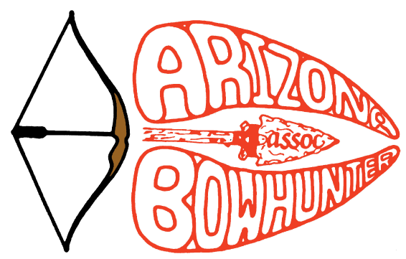
FOR IMMEDIATE RELEASE
Contact: AJ Murosky
Phone: 602-579-1388 E-mail: deerguy@yahoo.com
Date: January 2, 2020

Arizona Bowhunters Association Awards Scholarship Winners
ABA Foundation arm awards $2,250 in scholarship funding

PHOENIX, AZ… The Arizona Bowhunters Foundation awarded a total of $2,250 in scholarship funds on December 7th for their 2019 AZGFD Intern Scholarship Program. The three winners received their funds and were also invited for recognition at the Annual ABA/BIA Banquet to be held on March 28, 2020. The three (3) individual winners are:

FIRST PLACE, $1,000: LEAH BELL
Leah is 22 years old and a Senior at the University of Wisconsin - Stevens Point (UWSP), majoring in Wildlife Ecology and Management. She interned for the AZGFD Small Mammal Research Branch studying the endangered New Mexico Jumping Mouse along with working with survey programs for amphibians, ospreys and bighorn sheep.

SECOND PLACE, $750: RYAN HILL
Ryan is 22 years old and a Senior at Arizona State University, majoring in Applied Biological Sciences with a focus in Natural Resource Ecology. He interned for the AZGFD Canyon Creek Hatchery working with cold-water sport fish species of Trout and Grayling.

THIRD PLACE, $500: ANTON EBENAL
Anton is 23 years old and a Senior at the University of Arizona, majoring in Natural Resources with an Emphasis in Fisheries Management. He interned in the AZGFD Aquatics Branch and his duties included assisting with various native fish conservation projects.

This new program of the ABA’s Walt Collins Scholarships was created exclusively for Arizona Game & Fish Department interns who worked in 2019 and did complete their work assignment, to a satisfactory degree, according to the AZGFD Human Resources Office. The 78 interns of 2019 are working towards degrees in various outdoor career applications in Biology, Wildlife and Fisheries, Natural Resources, Forestry, Wildlife Management, and Wildlife Conservation.

“The ABA is an active member of the AZGFD Hunting and Angling Heritage Work Group. As we have worked with fellow outdoor organizations, we are learning that even though we are all separate groups, we have the same goals of the 3 R’s…recruiting, retaining and reactivating outdoorsmen and outdoorswomen. Taking that thought to the next level led us to looking at the intern program as a place where we could help. Obviously, we would love for everyone to become an archer, but the reality is these interns are going to be the ones that help mold the future of our great outdoors,” says AJ Murosky, Scholarship Committee Chairman.

Kayla Wall, Committee member explained, “After going through this entire process, we were very impressed with the quality of the applications submitted by all of the AZGFD interns. However, these three individuals stood out and we are very proud to be awarding these scholarships to such outstanding young men & women who are working so hard to create lifelong careers!”

Committee member, Scott Tyer, added, “We are already tweaking the application for next year’s batch of interns to see how they can use their future careers toward the 3 R’s. And, we have also started brainstorming another scholarship program which will be more archery oriented, but more on that later this year!”

ABOUT THE ARIZONA BOWHUNTERS ASSOCIATION

The ABA is a 501c3 non-profit organization whose mission is to foster, perpetuate, and expand Bowhunting and Bowhunting ethics in Arizona. They partner with various non-profit HAHWG member groups to fulfill an ever-expanding amount of works to help recruit, retain and reactivate outdoorsmen & outdoorswomen and to help kids experience the great outdoors. The ABA’s Bowhunter Happening is one of the largest archery shoots in Arizona and will be held on July 17, 18 & 19 at Mormon Lake, AZ. The Bowhunter Happening will also be hosting the 40th Anniversary of the Paul Line’s Big Bear Kids Course where kids under 8 get to learn about animals and how to safely shoot a bow & arrow.
For more information, please visit: www.arizonabowhunters.org

# # #

